

**Research & Vehicle Technology**

**“Infotainment Systems Product Development”**

**Feature: Cluster Theme Selection**

**Subsystem Part Specific Specification (SPSS)**

Version 1.0

**UNCONTROLLED COPY IF PRINTED**

**Version Date: August 24, 2020**

**FORD CONFIDENTIALF**

**Revision History**

|  |  |  |  |  |
| --- | --- | --- | --- | --- |
| **Date** | **Version** | | **Notes** | |
| **Aug 26, 2020** | **1.0** | | **Initial Release** |  |
| **Feb 22,2021** | **1.1** | |  | **Update the default value as reserved in chapter 2.1** |
| **July 7,2021** | **1.2** | |  | **Add CD764 theme mapping** |
|  |  |  | |  |
|  |  |  | |  |
|  |  | | |  |

**Table of Contents**

Revision History 2

1 Architectural Design 4

1.1 Overview 4

1.2 Theme Selection Client 4

1.3 Theme Selection Server 4

1.4 Interface Requirement 4

1.4.1 FBMP Interface requirements 4

1.4.2 Theme Selection Setting Client Tx 5

1.4.3 Theme Selection Setting Client Rx 5

2 General Requirements 6

2.1 Feature definition 6

2.2 General Requirement 6

2.2.1 Client HMI update 6

2.2.2 Storage Strategy 6

2.2.3 Default Setting 6

2.2.4 Error handling 6

3 Functional Definition 8

3.1 Use Cases 8

3.1.1 Theme Switch 8

3.1.2 Link to Drive Mode 8

3.1.3 Not link to Drive Mode 8

3.2 Sequence Diagrams 8

4 Appendix: Reference Documents 10

# Architectural Design

## Overview

Theme Selection feature should support the Theme Selection Client(ex. IVI..) to control the theme of Theme Selection Server(ex. IPC..), for both side use the same theme.

## Theme Selection Client

The Theme Selection Client is responsible for sending the Feature2.Rq HMI settings to the Theme Selection Server.

## Theme Selection Server

Theme Selection Server receives requests from the Theme Selection Client and perform the request operation and update the Feature2.St message. Theme Selection Server shall remember the updated setting between power mode changes.

## Interface Requirement

### FBMP Interface requirements

#### Feature_St/ Feature2_St

Message Type: Status

Represents the current status of a feature (feature selected, feature setting, etc.).

Included Parameters:

FeatureID

Configuration

PersIndex

|  |  |  |  |
| --- | --- | --- | --- |
| **Name** | **Literals** | **Value** | **Description** |
| FeatureID | **-** | **-** | Active feature number |
|  |  | 0x0000 – 0xFFFF |  |
| Configuration | **-** | **-** | Active configuration value |
|  |  | 0x0000 – 0xFFFF |  |
| PersIndex | **-** | **-** | Indicates which personality profile is active |
|  | PERS_1 | 0x0 |  |
|  | PERS_2 | 0x1 |  |
|  | PERS_3 | 0x2 |  |
|  | PERS_4 | 0X3 |  |
|  | VEHICLE | 0X4 |  |
|  | Not Used | 0x5 |  |
|  | Not Used | 0x6 |  |
|  | Not Used | 0x7 |  |

#### A-Feature_Rq/ Feature2_Rq

Message Type: Request

Represents the request to command a feature change (select new feature, change feature setting, query features, etc.).

Included Parameters:

Operation

FeatureID

Configuration

PersIndex

|  |  |  |  |
| --- | --- | --- | --- |
| **Name** | **Literals** | **Value** | **Description** |
| Operation | **-** | **-** | Type of operation being requested |
|  | Null | 0x0 |  |
|  | Query | 0x1 |  |
|  | Set | 0x2 |  |
|  | Upload | 0x3 |  |
|  | Restore | 0x4 |  |
|  | Copy | 0x5 |  |
|  | NotUsed | 0x6 – 0x7 |  |
| FeatureID | **-** | **-** | Feature number being requested |
|  |  | 0x0000 – 0xFFFF |  |
| Configuration | **-** | **-** | Configuration value being requested |
|  |  | 0x0000 – 0xFFFF |  |
| PersIndex | **-** | **-** | Indicates which personality profile is being accessed |
|  | PERS_1 | 0x0 |  |
|  | PERS_2 | 0x1 |  |
|  | PERS_3 | 0x2 |  |
|  | PERS_4 | 0X3 |  |
|  | VEHICLE | 0X4 |  |
|  | Not Used | 0x5 |  |
|  | Not Used | 0x6 |  |
|  | Not Used | 0x7 |  |

### Theme Selection Client Tx

|  |  |
| --- | --- |
| Feature2.Rq : Operation | CtrStkDsplyOp2_D_Rq |
| Feature2.Rq : FeatureID | CtrStkFeat2NoActl |
| Feature2.Rq : Configuration | CtrStkFeat2ConfigActl |
| Feature2.Rq : PersIndex | CtrStkPersIndex2_D_Actl |

### Theme Selection Client Rx

|  |  |
| --- | --- |
| Feature2.St : FeatureID | FeatNoIpc2Actl |
| Feature2.St : Configuration | FeatConfigIpc2Actl |
| Feature2.St : PersIndex | PersIndexIpc2_D_Actl |

# General Requirements

## Feature definition

For this feature when performing the “Set” or “Query” operation the Feature Number and Configuration Number in the Feature2.Rq and Feature2.St messages shall be used below.

If Enhanced Memory is supported the Active Personality Profile shall be used for PersIndex. If Enhanced Memory is not supported PersIndex shall be set to Vehicle.

The below table shows the CAN signals values to be defined

|  |  |  |  |
| --- | --- | --- | --- |
| **Feature Description** | **Feature Number** | **Configuration Number** | **HMI selection / Configuration Name** |
| Theme Selection | 0x09C0 | 0x00 | Link with Drive Mode |
| 0x01 | Default Theme - Reserved |
| 0x02 | Theme 1 |
|  |  | 0x03 | Theme 2 |
|  |  | 0x04 | Theme 3 |
|  |  | 0x05 | Theme 4 |

Note： for CD764 0x02 theme 1 – Normal single

0x03 theme 2 – Sport

0x04 theme 3 – Eco

0x05 theme 4 – Normal Dual

## General Requirement

* At start-up the Theme Selection Client shall not query 0x09C0.
* At start-up the Theme Selection Client shall set 0x09C0.
* When user change the settings, Theme Selection Client shall perform the Feature2.Rq Set to 0x09C0.
* The definition about the Configuration Number:
  + If the end user selects the theme link with drive mode switch, Configuration Number shall be 0x00, both the Client and Server theme shall follow the drive mode.
  + If the end user selects the theme not link with Drive mode, Configuration Number shall be set as other !0x00 value. The detail value shall be defined according to programs. Theme Selection Server shall follow the theme setting from Theme Selection Client.

### Client HMI update

The request from the Theme Selection Client does not require the Theme Selection Server to reply with an updated status to update their HMI.  (Example, Client sends request theme1 to Server, Server ignores or not set the theme successfully and not send the Feature2.St. Client updates HMI with theme1 and stores internal the value)

### Storage Strategy

The Theme Selection Client and Server shall retain the value for the across ignition cycles and sleep cycles. Theme Selection Server shall use the last valid value if not get the valid value.

### Default Setting - TBD

The Theme Selection Setting Client and Server shall use the same default setting based on alignment.

### Error handling

The Theme Selection Setting Server shall feedback status to the Client using the Feature2.St.

* Note: For error handling details need reference <FBMP-REQ-023017/B-Set request but no response from Feature Server (TcSE ROIN-287260-1)> in FBMP APIM SPSS

# Functional Definition

## Use Cases

### Theme Switch

|  |  |
| --- | --- |
| **Actors** | User |
| **Pre-conditions** | Infotainment System is On.  theme is set to {theme X} |
| **Scenario Description** | User selects <theme Y> V via the HMI |
| **Post-conditions** | Client and Server HMI is update to {theme Y} |
| **List of Exception Use Cases** |  |
| **Interfaces** |  |

### Link to Drive Mode

* If the end user selects the theme link with drive mode switch, Configuration Number shall be 0x00, both the Client and Server theme shall follow the drive mode.

|  |  |
| --- | --- |
| **Actors** | User |
| **Pre-conditions** | Infotainment System is On.  theme is set to {theme X} |
| **Scenario Description** | User select the <Link to Drive mode> |
| **Post-conditions** | Client and Server theme shall follow the drive mode, the setting HMI shall follow the HMI definition |
| **List of Exception Use Cases** |  |
| **Interfaces** |  |

### Not link to Drive Mode

* If the end user selects the theme not link with Drive mode, Configuration Number shall be set as other !0x00 value

The detail value shall be defined according to programs. Theme Selection Setting Server shall follow the theme setting from Theme Selection Setting Client.

|  |  |
| --- | --- |
| **Actors** | User. |
| **Pre-conditions** | Infotainment System is On. |
| **Scenario Description** | User select the <not link to Drive mode>  theme is set to {theme X} |
| **Post-conditions** | Server shall follow the theme settings from Client as {theme X} |
| **List of Exception Use Cases** |  |
| **Interfaces** |  |

## Sequence Diagrams

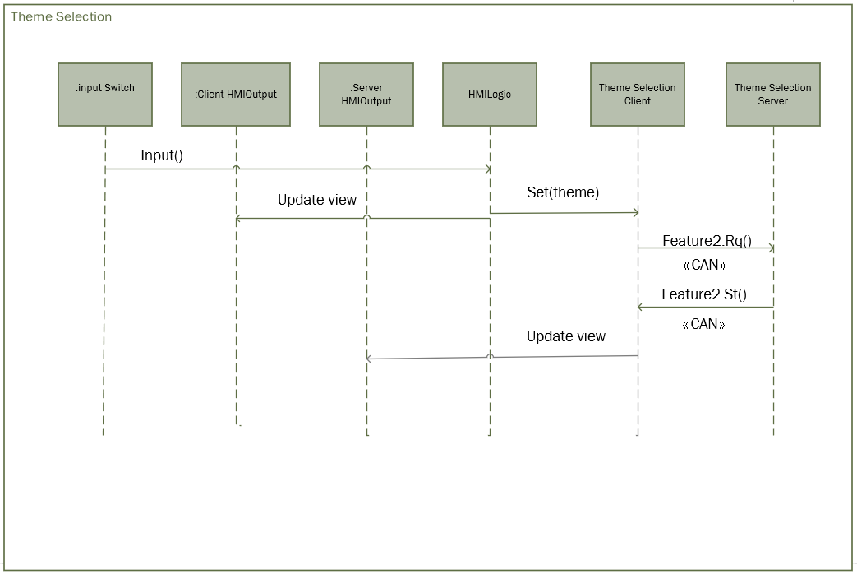

# Appendix: Reference Documents

Feature Based Messaging Protocol SPSS

Setting in Infotainment CenterStack SPSS